BCIS-5610 DATA WAREHOUSING
BY
PROF KASHIF SAEED

Assignment 2- DIMENSIONAL MODELING
BY
SAI SNEHA AARIGA

DIMENSIONAL MODELLING DIAGRAM

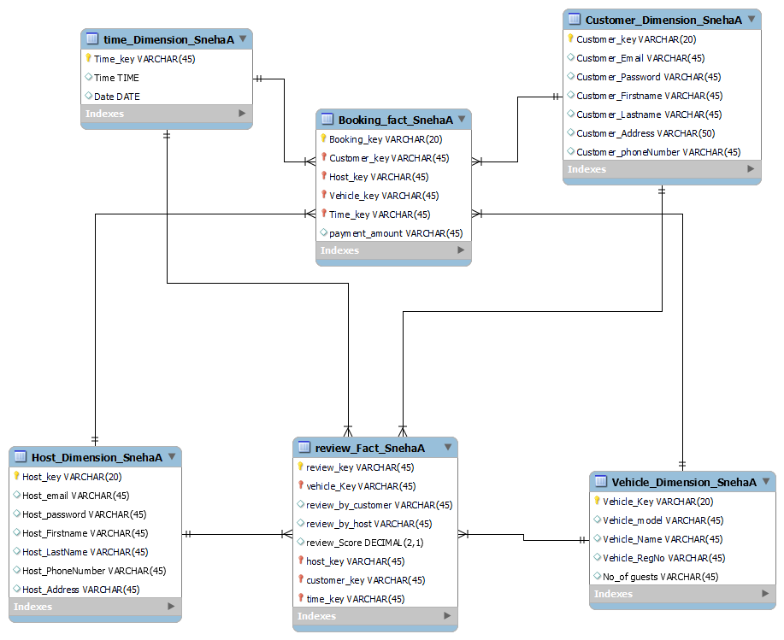

Images of Dimensional Tables, Fact Tables, and related Populated Tables

There are six total tables in this data base, four of which are dimensional tables and two of which are fact tables.

- Customer_Dimension_SnehaA
- Host_Dimension_SnehaA
- Vehicle_Dimension_SnehaA
- Time_Dimension_SnehaA
- Booking_Fact_SnehaA
- Review_Fact_SnehaA

1.Customer_Dimension_SnehaA :

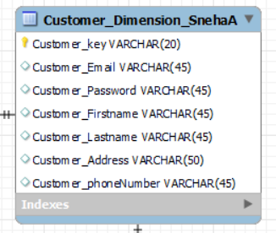

Due to its connections to numerous fact tables, such as the booking Fact and Review Fact, it is a confirmed dimension.

Dimension Table filled with details:
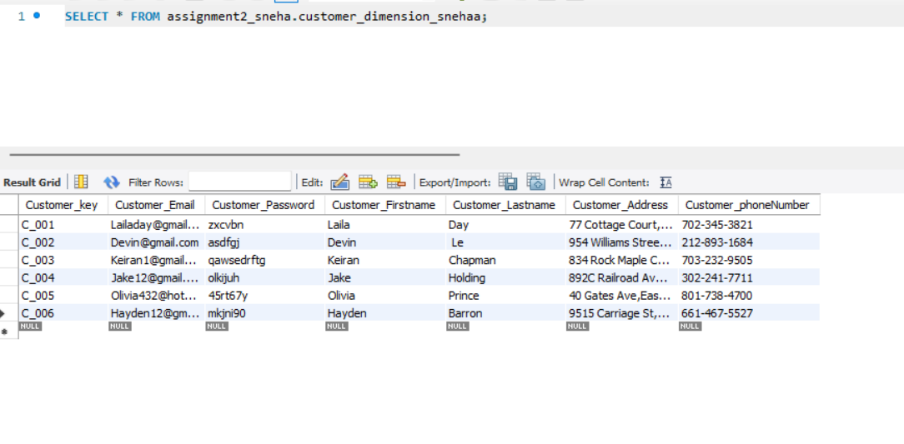
2.Host_Dimension_SnehaA:
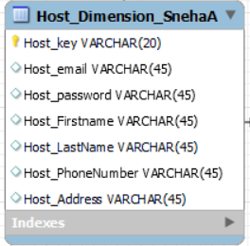

Due to its connections to numerous fact tables, such as the booking Fact and Review Fact, it is a confirmed dimension.

Dimension Table filled with details:
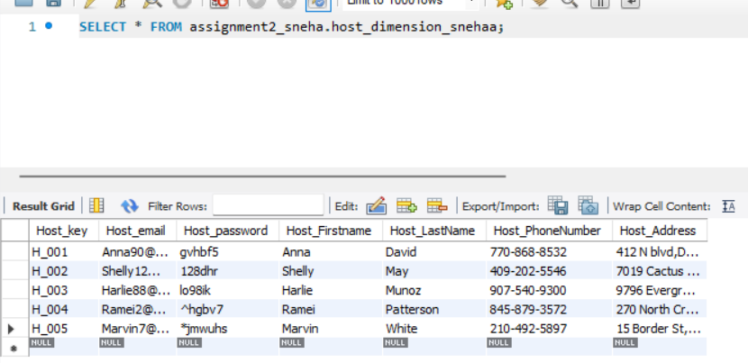

3.Vehicle_Dimension_SnehaA

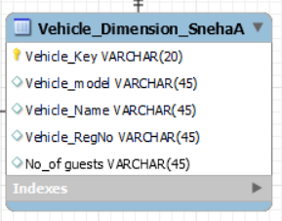

Due to its connections to numerous fact tables, such as the booking Fact and Review Fact, it is a confirmed dimension.

Dimension Table filled with details:

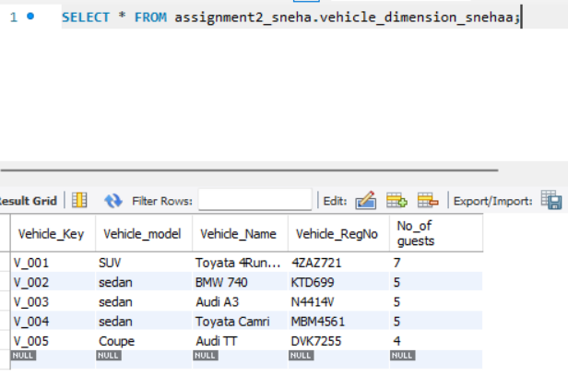
4.Time_Dimension_SnehaA
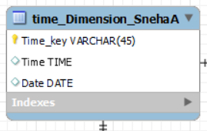

At Daily Grain, the time dimension is captured.
Due to its connections to numerous fact tables, such as the booking Fact and Review Fact, it is a confirmed dimension.
It is also a role-playing dimension as it is playing different roles.

Dimension Table filled with details:

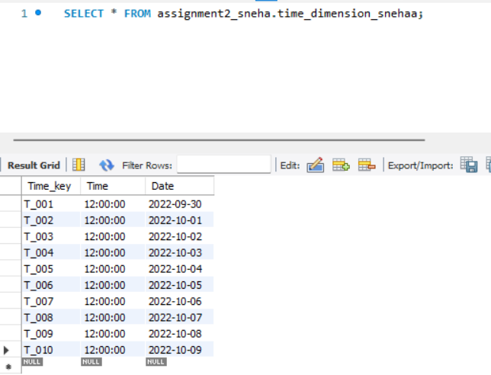

5.Booking_Fact_SnehaA
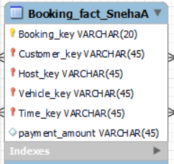

It is a fact table as it contains the measures i.e Payment_amount

Fact Table filled with details:
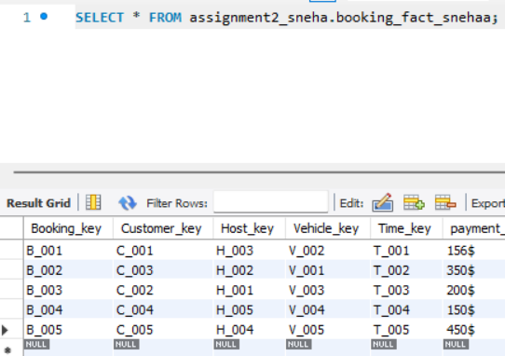

6.Review_Fact_SnehaA

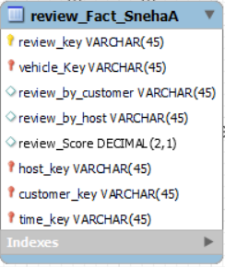
It is a fact table as it contains the measures i.e review score

Fact Table filled with details:
